# **[React JS- Complete Guide for Frontend Web Development [2022]](https://www.udemy.com/course/react-js-a-complete-guide-for-frontend-web-development/)**

HTML stands for Hyper Text Markup Language and is used for creating the structure while,

CSS is used for styling and formatting elements and JAVASCRIPT is responsible for adding functionality to that webpage.

**HTML Code Editor Setup**

https://codepen.io/  
copy the URL and share

<https://codepen.io/a4abhishekkmr/pen/mdKjQNj?editors=1000>

or

use VS Code (Helpful with supercool Extensions)

Install Live Server and right click on any code to get the local url opened into Browser and watch updating live. <http://127.0.0.1:5500/Start.html>

**HTML Structure of an HTML Document**

<!DOCTYPE html> document type

<html> container of html elements

<head> Stores meta data of syles links and data

<meta charset=”UTF-8”> technical info like page formatting of webpage

<title> My first Page</title> Displays on tab

</head>

<body> main body containing tag and its content

</body>

</html>

Paired Tags :- Need closing Tags like h1 and so on

Other hand we have img and br tags no needs to be paired tags.

**HTML Heading tag**

<h1>I am a h1 Heading</h1>

<h2>I am a h2 Heading</h2>

<h3>I am a h3 Heading</h3>

<h4>I am a h4 Heading</h4>

<h5>I am a h5 Heading</h5>

<h6>I am a h6 Heading</h6>

**HTML – Paragraph, Bold, Italic, Breakline(br), pre tag**

<p> Hello this is <b>Abhishek Kumar</b> and I am from <i>Ramgarh, Jharkhand</i> and

<br/> recently I had completed my Graduation in Computer Science and Engineering from SRM University in 2022.

</p>

**Pre Tag is used to be printed as it is, like even if it is in next line then in browser also it will be on the next line.**

<pre>

Hello this is Abhishek Kumar,

And I am from Ramgarh Jharkhand.

Recently I have Completed my Graduation,

From SRM University Chennai.

</pre>

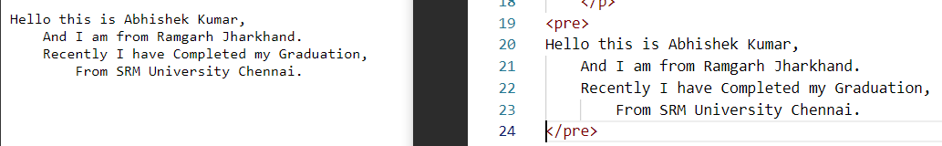

**HTML Adding Images**

<img/> Non Paired Tag.

Two attributes Source (src) and alternate text(alt)

<img src="photo1.jpg" alt="Abhishek's picture" width=”600” height=”500”/>

Use forward slash to get list of files and folders.

# HTML Ordered and Unordered List

<ul>

    <li>Mercury</li>

    <li>Venus</li>

    <li>Earth</li>

</ul>

<ol type="A">

    <li>Mercury</li>

    <li>Venus</li>

    <li>Earth</li>

</ol>

Types of OL:-

* 'a' indicates lowercase letters,
* 'A' indicates uppercase letters,
* 'i' indicates lowercase Roman numerals,
* 'I' indicates uppercase Roman numerals,
* and '1' indicates numbers (default).

By default it is 1. So if you wont type type then it will goes on like 1,2,3…

# Adding Styles and Formatting HTML elements

Style in images

<img src="photo1.jpg" alt="Abhishek's picture" style="width: 100%; height:600px"/>

Html bydefault uses page margin as 8px;

We can change it to 0 as in body

<body style="margin: 0;">

**Margin is the space between the element and border**

Margin top/left/right/bottom in h1

<h1 style="margin-top: 20px;">I am a h1 Heading</h1>

Allign text to center

<h2 style="text-align: center;">I am a h2 Heading</h2>

Font size bigger and Background color

<h3 style="font-size: 48px;">I am a h3 Heading</h3>

<h4 style="background-color: red;">I am a h4 Heading</h4>

Padding in the paragraph: only padding means all sides.

<p style="padding: 20px;"> TEXT</p>

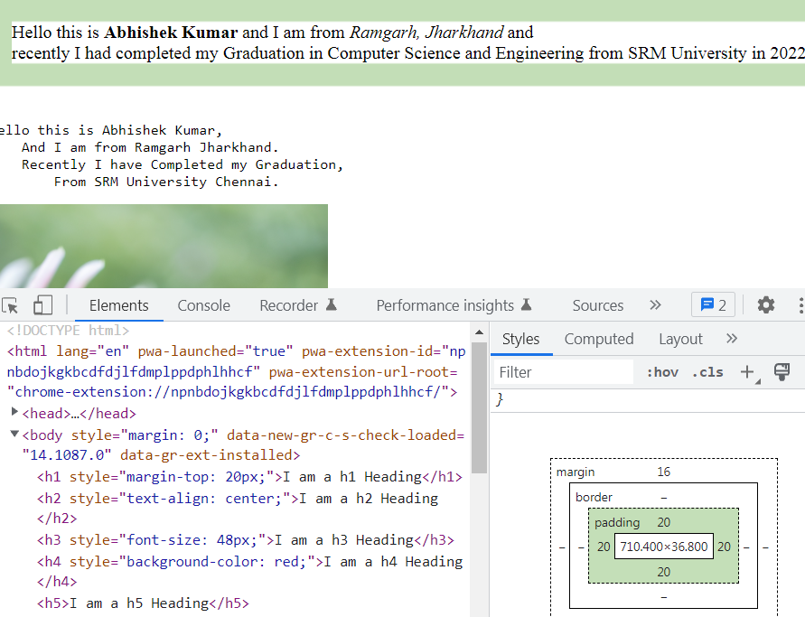

Font size of paragraph

<p style="padding: 20px;font-size:large">

**Line Height :- Increases Space between the texts**

<p style="padding: 20px;font-size:large;line-height:1.5;”>

Background Color to Entire Page

<body style="margin: 0;background-color:aqua">

Font color for Heading <h5 style="color:blue">I am a h5 Heading</h5>

# HTML - Block and Inline Display Values

**Block Elements take the entire width of the screen while inline takes the required amount of width required.**

Some block elements are h1-h6, form, footer, table, ul, p, ol, header, hr, div, address, video etc.

While inline examples are b, img, map, script, button, output etc.

**Div:- It is like container for HTML elements.**

<div style="background-color: aqua;">

        <h2>This is a heading</h2>

        <p>This is another paragraph</p>

    </div>

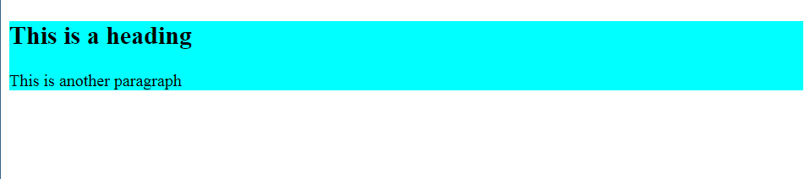

Taking the whole width of screen

Now inline Elements

    <span style="background-color: aqua;">Home</span>

    <span style="background-color: red;">About</span>

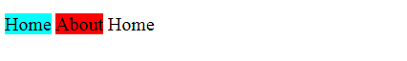

Only the required space

# HTML – Adding Group Styles using Class Attribute

Problem arises when I have multiple elements inside a container. Lets suppose List of Paragraphs and some images are there and to **Modify** it I need to change in all the attributes of p and img let’s suppose hundreds of paragraphs. So instead of that lets put all of these inside a class and then by changing class properties what we will find is we have less human efforts to solve or modify the page.

<head>

    <style>

        .image {

            width:200px;

            height:300px;

        }

    </style>

    <title>In page class</title>

</head>

<img class="image" src="/photo1.jpg" alt="no image"/>

<img class="image" src="/photo1.jpg" alt="no image"/>

<img class="image" src="/photo1.jpg" alt="no image"/>

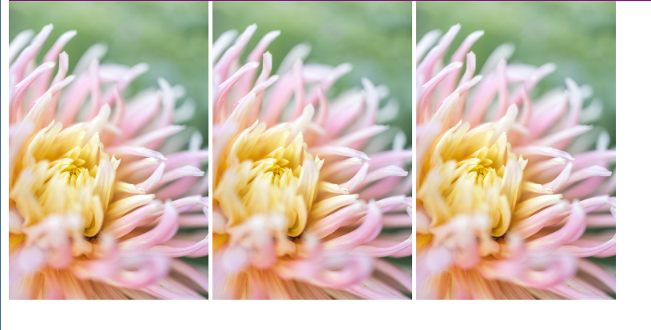similarly we can make class for paragraphs and Headings.

# HTML- Adding Hyperlinks in webpages

Anchor tags(a) is used along with href for hyperlinks.

<a href="https://a4abhishekkmr.github.io">My Portfolio</a>

To open in new tab we need to use target

<a href="https://a4abhishekkmr.github.io" target="_blank">My Portfolio</a>

Now lets create an Image to an hyperlink

<a href="https://a4abhishekkmr.github.io" target="_blank">

<img src="/photo1.jpg" alt="Hello" width="200" height="200"/></a>

Now we will link different Webpages

<li class="menu"><a href="https://a4abhishekkmr.github.io" target="_blank">Home</a></li>

        <li class="menu"><a href="https://a4abhishekkmr.github.io" target="_blank">About</a></li>

        <li class="menu"><a href="/HtmlFeatures.html" target="_blank">Contact</a></li>

# Uniquely Identity html Elements using ID

Use id to give styling to our elements

To catch uniquely each and every elements like images paras and all.

<head>

<style>

#topbar{

            font-size: x-large;

            color: blueviolet;

            background-color: aqua;

            width: 100%;

            padding:16px;

        }

</style>

</head>

<li id="topbar"><a href="https://a4abhishekkmr.github.io" target="_blank">Home</a></li>

Now this will acts uniquely as defined by the id denoted by #.

A element can have both id as well as class

<li class="menu" id="topbar"><a href="https://a4abhishekkmr.github.io" target="_blank">About</a></li>

Id was given more preference.

# Bookmark in a webpage

<head>

    <style>

        .menu{

            font-size: larger;

            color: blue;

            background-color: bisque;

            height: 1000px;

            padding: 12px 16px;

        }

        #second{

            background-color: blue;

        }

        #third

        {

            background-color: aquamarine;

        }

    </style>

…

<li class="menu"><a href="/Html3.html#second">Go to Second</a></li>

        <li class="menu" id="second"><a href="/Html3.html#third">Go to Third</a></li>

        <li class="menu" id="third"><a href="/HtmlFeatures.html">Hurray i am the last. Now go to top</a></li>

When clicking 1st Line it jumps to the second due to #second and id mentioned is second.

Similary clcking Go to third jumps to the third id

# Unordered List Styles

<ul style="list-style-type: none">

|  |  |
| --- | --- |
| **Value** | **Description** |
| * disc | * Sets the list item marker to a bullet (default) |
| * circle | * Sets the list item marker to a circle |
| * square | * Sets the list item marker to a square |
| * none | * The list items will not be marked |

HTML4 vs HTML5

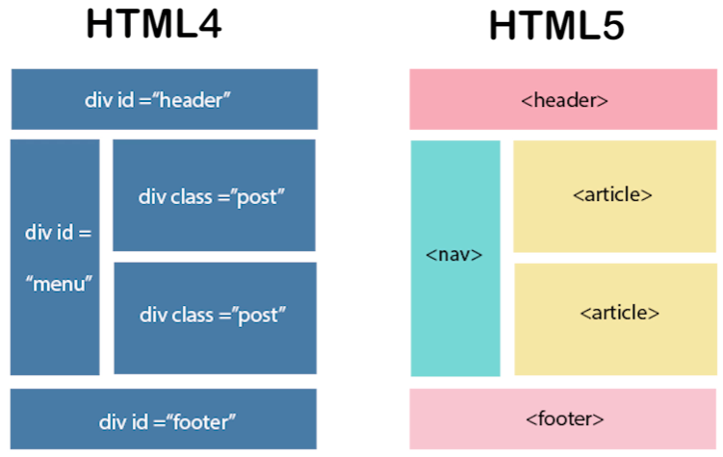

HTML5 will know where is footer and header along with nav.

Html5 also have inbuilt support for video and audio files while HTML4 does’nt have.

Also, HTML5 has inbuilt support of vector graphics live SVG and canvas.

HTML5 also supports multiple storage options like Application Cache, SQL database, web Storge while html4 only cookies.

IN html5 JS web Worker API allows JS and browser to run on different threads while html4 works on same threads leads performance issue.

# Design Page Structure using Semantic Tag

**Structural Elements:-**These tags just define the structure of HTML page.

Doesn’t provide what kind of data rendered by the HTML page to the browsers. Like div, span etc.

**Semantic Tags:-** These tags just define the structure as well as **meaning of the content** of HTML page.

They provide what kind of data rendered by the HTML page to the browsers. Like header, nav, main etc.

    <header id="header">

        <nav id="navbar">

            <span>Menu 1</span>

            <span>Menu 2</span>

            <span>Menu 3</span>

        </nav>

    </header>

    <main id="main-section">

        <section id="section">

            <article id="article">

                    <h3>Article title 1</h3>

                    <a href="Html3.html">Author One</a>

                </header>

                    <p>Hello this is Abhishek and i am enjoying html5</p>

            </article>

            <article id="article">

                <header>

                    <h3>Article title 2</h3>

                    <a href="Html3.html">Author Two</a>

                </header>

                    <p>Hello this is Abhishek and i am enjoying html5</p>

            </article>

        </section>

    </main>

    <footer id="footer">

        Copyright 2022

    </footer>

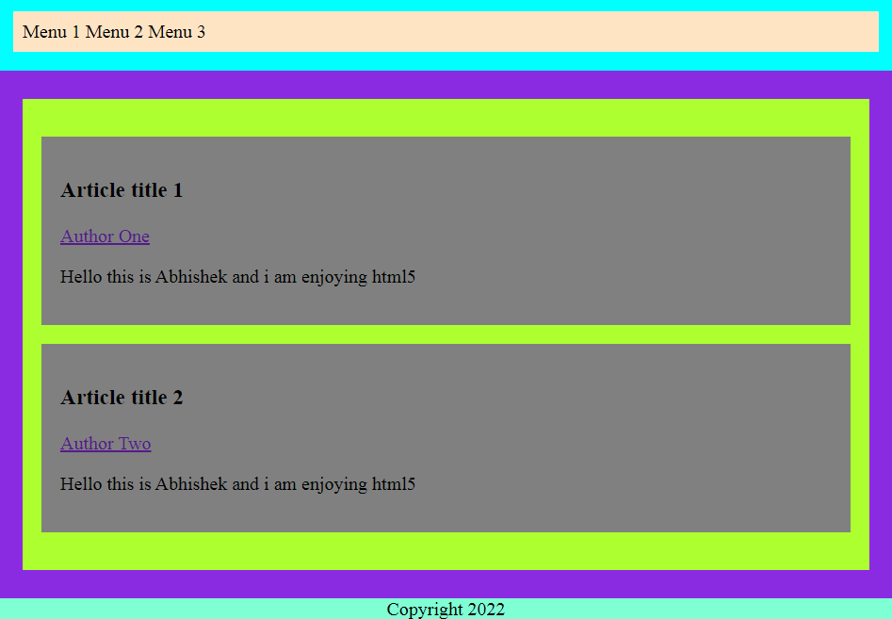

Details and Summary

 <details>

        <summary>

            Chapter One

        </summary>

        <p> this is an introduction to hidden magic</p>

    </details>



Becomes after clicking

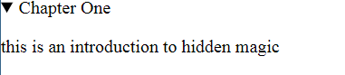

# Tables in HTML page

<style>

        table,td,th{

            border: 1px solid black;

            border-collapse: collapse;

            font-size: 24px;

        }

        td{

            padding:16px;

        }

        table{

            width: 600px;

            background-color: aqua;

            margin-top: 24px;

            margin-left: 24px;

        }

    </style>

…

<table>

        <caption>My Secret TimeTable</caption>

        <tr>

            <th>Mon</th>

            <th>Tue</th>

            <th>Wed</th>

            <th>Thu</th>

            <th>Fri</th>

        </tr>

        <tr>

            <td>Maths</td>

            <td>Science</td>

            <td>S.S.t</td>

            <td>Hindi</td>

            <td>English</td>

        </tr>

        <tr>

            <td>Maths 1</td>

            <td>Science 1</td>

            <td>S.S.t 1</td>

            <td>Hindi 1</td>

            <td>English 1</td>

        </tr>

        <tr>

            <td>Maths 2</td>

            <td>Science 2</td>

            <td>S.S.t 2</td>

            <td>Hindi 2</td>

            <td>English 2</td>

        </tr>

        <tr>

            <td>Maths 2</td>

            <td>Science 2</td>

            <td>S.S.t 2</td>

            <td>Hindi 2</td>

            <td>English 2</td>

        </tr>

    </table>

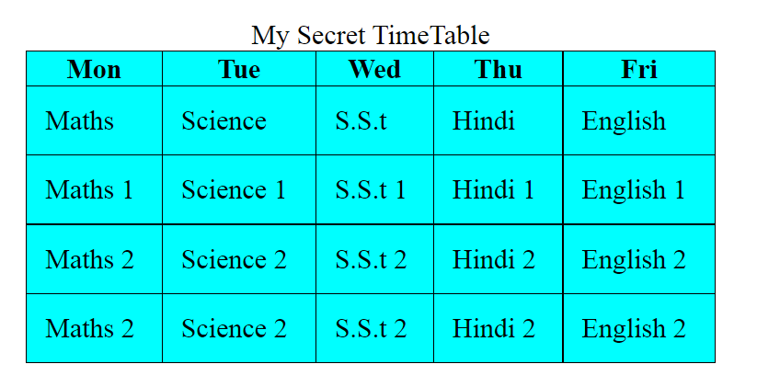This is how a basic time-table is made.

# Span Table rows and Columns

Rowspan and colspan

<tr>

            <td colspan="5" style="text-align: center;">Lunch Break</td>

        </tr>

………………………

<tr>

            <td rowspan="6">Hours</td>

            <th>Mon</th>

            <th>Tue</th>

            <th>Wed</th>

            <th>Thu</th>

            <th>Fri</t

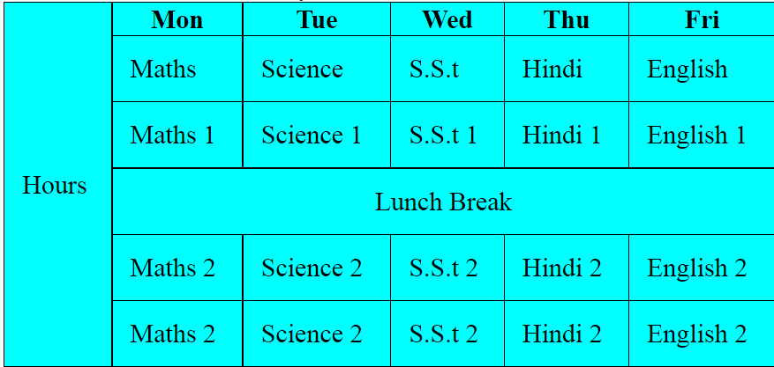

# Design Layouts using Tables

I will make a table which will contain 3 images on a row and 2 rows of content.

<table>

        <tr>

            <td>

                <img class="food" id="sand" src="/Assets/sandwich.jpg" alt="sandwih"/>

                <h3>Sandwich</h3>

        </td>

        <td>

        <img class="food" id="burg" src="/Assets/burger.jpg" alt="burg"/>

        <h3>Burger</h3>

    </td><td>

        <img class="food" id="pav" src="/Assets/pav.jpg" alt="pav"/>

        <h3>Pav Bhaji</h3>

            </td>

        </tr>

        <tr>

            <td>

                <img class="food" id="maggi" src="/Assets/maggi.jpg" alt="maggi"/>

                <h3>Maggi</h3>

        </td><td>

        <img class="food" id="momo" src="/Assets/momo.jpg" alt="momo"/>

        <h3>Momos</h3>

        </td><td>

        <img class="food" id="noodles" src="/Assets/noodes.jpg" alt="noodles"/>

        <h3>Noodles</h3>

            </td>

        </tr>

    </table>

# HTML Forms

Lets create a login form along with submit button

<form>

        <input type="text" name="username">

    </form>

Type can be date text, and any other field and name is used to identify while using or fetching it to the backend.

<input type="password" name="password">

</br>

<input type="submit" value="Click to Submit">

        <div>

            Gender:</br>

            <input type="radio" name="male" value="male">Male</input>

            <input type="radio" name="female" value="female">Female</input>

            <input type="radio" name="other" value="other">Others</input>

        </div>

        <div>

            Security Question:<br>

            <select name="security-question">

                <option>What was your first Pet name?</option>

                <option>What was your first School name?</option>

                <option>What was your first Crush name?</option>

            </select>

        </div>

        <div>

            <textarea name="answer" rows="6" cols="30"></textarea>

        </div>

        <div>

            <input type="checkbox" name="terms-conditions" value="accept">

            I agree to Accept all the terms and Conditions.

        </div>

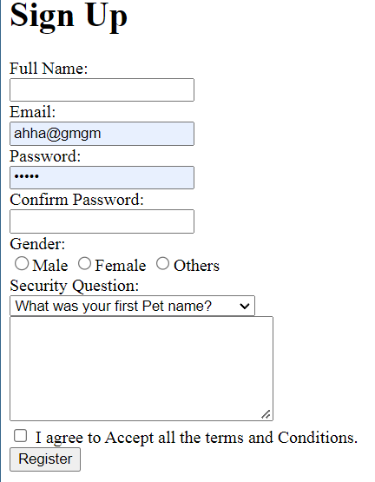

# Form Methods: Get and Post

To Reach to the backend we use Get or Post

Get has a limit of 300 chars and cant be useful to send Important data such as password and all because it can be visible from the url if we submit it.

While Post does’nt have limitations and it works behind the scene for which we are not supposed to be bothered of.

# New Form: Datalist and Output

Dropdown and auto complete textbox to select items from the list like  
choose your college

    <form>

        <input list="technologies" name="technology"/>

        <datalist id="technologies">

            <option value="HTML"></option>

            <option value="CSS"></option>

            <option value="JAVAScript"></option>

            <option value="React.js"></option>

            <option value="JAVA"></option>

            <option value="C++"></option>

            <option value="Python"></option>

        </datalist>

    </form>

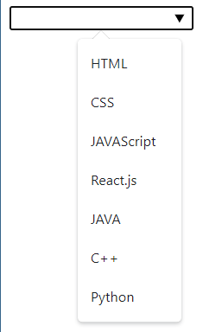

# New Form: Input type

<form>

        Username:</br>

        <input type="text" name="username">

    </br>

        Password:</br>

        <input type="password" name="password">

        <br>

        <input type="date" name="date" max="1999-01-01">

        <br>

        <input type="reset" value="Reset">

        </form>

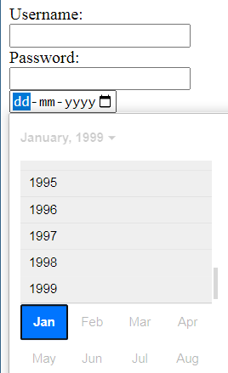Reset button is used to reset the fields

# New Form: Placeholder and Autofocus

<input class="input-item" type="text" name="full-name" placeholder="Full Name">

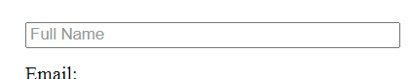

TO put in focus mode of a current tab such that whenever we opens the site that element will start highlighting with cursor blinking.

<input class="input-item" type="text" name="full-name" placeholder="Full Name" autofocus>

Multiple is used to select multiple Options from the dropdown

<select name="security-question" class="input-item" multiple>

To select multiple use ctrl and then click

# Form Validation

<input class="input-item" type="email" name="email" required>

**Required**:- Makes it compulsory to fill while clicking submit

**MaxLength:-**  cant write above this char limit

<input class="input-item" type="password" name="password" maxlength="8" required>

**Min and Max**:- These are the limits used to boundary the input.

<input class="input-item" type="number" min="18" max="80" name="age" required>

# Media on Webpage

Starts with Adding a video

    <video controls width="360" height="240">

        <source src="/Assets/thor.mp4" type="video/mp4">

    </video>

Control gives access to play the content.webp, and other formats also available.

<video controls width="360" height="240" autoplay>

This autoplay helps to play automatically whenever we reaches the site.

**Adding Audio**

<audio controls>

        <source src="/Assets/sunrise.mp3" type="audio/mp3">

    </audio>

Again controls is Important. Wav, ogg is all Accptable.

Now Embed is used for swf(Small web format) flash files.

<embed width="200" height="150" src="/Assets/sample.swf">

Now this iframe helps to add New website inside a website

<iframe height="600px" width="400px" src="https://a4abhishekkmr.github.io"></iframe>

Now to add Youtube Video

Right click on the Video and Select the EMbeded code option. And paste it on the webpage

<iframe width="702" height="395" src="https://www.youtube.com/embed/bRs6E_SL2Tk" title="Backtracking | N Queens Problem | Permutations | The Java Placement Course | Apna College |" frameborder="0" allow="accelerometer; autoplay; clipboard-write; encrypted-media; gyroscope; picture-in-picture" allowfullscreen></iframe>

# Introduction to SVG

Scalar vector Graphis is a markup Language for describing two dimensional based vector graphics.

SVG images and their related behaviours are defined in XML files and can be created or edited with any text editor and with drawing software like Adobe premiere Pro.

<svg width="500px" height="500px" xmlns="http://www.w3.org/2000/svg">

<line x1="0" y1="0" x2="100" y2="100" stroke="red" stroke-width="3px"/>

</svg>

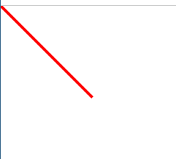

X1 and y1 are the coordinates of first point while x2 and y2 are of second point and this makes a line. With origin at top left.

If x changes then moves left and right as of X axis(horizontal) and due to Y – then line moves up and down(vertical)

Putting them in HTML by

<img src="/line.svg" alt="Line"/>

or

    <svg width="500" height="500">

        <line x1="0" y1="0" x2="100" y2="100" stroke="red" stroke-width="3px"/>

    </svg>

**Circle with Svg**

<svg height="100" width="100">

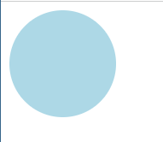        <circle cx="50" cy="50" r="50" fill="lightblue" />

        Sorry your browser dont supports svg

    </svg>

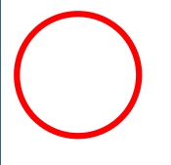Cx and cy are the coordinates of center while r is the radius and fill will fill the item with color.

Change in cx moves left or right while cy moves up and down

**To make a ring we will use stroke**

<circle cx="55" cy="55" r="50" fill="transparent" stroke="red" stroke-width="5px"/>

**Rectangle with SVG**

<svg width="500" height="500">

        <rect width="200" height="150" fill="aqua"></rect>

    </svg>

to move the object away from origin use x and y

<rect width="200" height="150" fill="aqua" x="20" y="20"/>

No need of closing tag

Change in x moves left/right while y moves up/down

Add a border same using the stroke

stroke="blue" stroke-width="8px"/>

To make the corners curved we need to add rx and ry.

<rect width="150" height="150" fill="aqua" x="20" y="20" stroke="blue" stroke-width="8px" rx="75" ry="75"/>

This results to a Circle

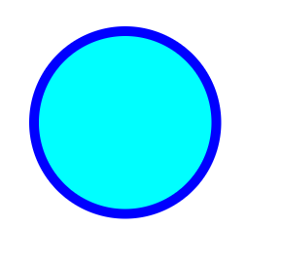

--- The End----